CRYPT-ARITHMETIC PROBLEM
Aim
To solve the Crypt-Arithmetic problem using Artificial Intelligence techniques by assigning unique digits to letters.
Objectives
- To understand constraint satisfaction problems.
- To assign digits to letters without repetition.
- To verify the arithmetic equation.
- To find a valid solution.
Algorithm
- Start.
- Define the equation SEND + MORE = MONEY.
- Generate all possible digit combinations.
- Assign digits to letters.
- Check if all letters have unique values.
- Verify the equation.
- If the equation is satisfied, display the solution.
- Stop

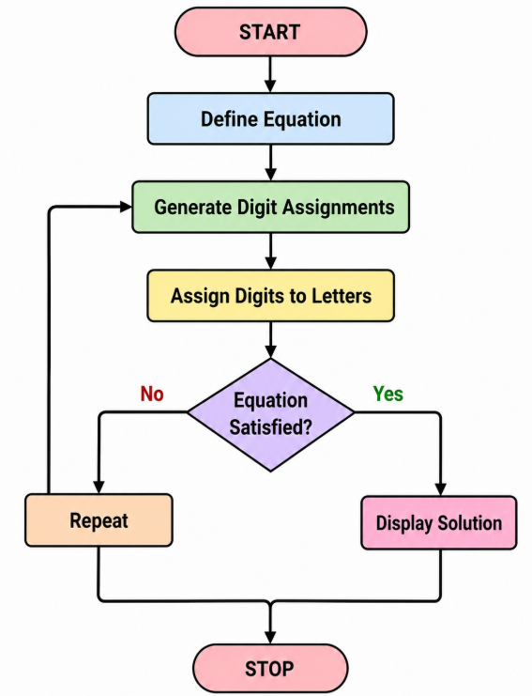
PROGRAM
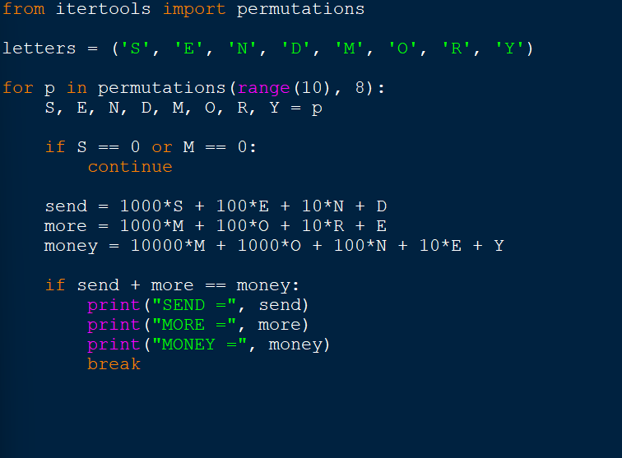
OUTPUT
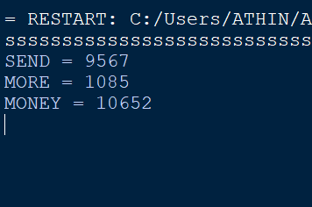
Result
The Crypt-Arithmetic problem was successfully solved, and a valid assignment of digits to letters was obtained.

